**Digitization Guidelines**

**National Institute of Japanese Literature (NIJL)**

**(August 1, 2024)**

1. When photographing, the images should be converted to image data as faithfully as possible. Image data format should be TIFF and JPEG. If either format cannot be provided, please consult NIJL.
2. When using a digital camera: Use a digital camera with a screen size of approximately 36 × 24 mm and an image sensor with an effective pixel count of 21 megapixels or more.
3. When using a scanner: The reading resolution should be full size and at least or more than 400 dpi.
4. Scale (see fig. 1):

・Photographs should be taken with a scale in place to clarify the dimensions of the material. The scale should be placed in the first frame of “box,” “bookcase,” “wrapper/envelope,” and “main document” of each material so that the height and width of the material can be seen.

・Place a scale horizontally or perpendicularly to the material as much as possible.

・Provide adequate margins between the material and the scale.

・As described in 6 (2), if you change the reduction rate, take another picture with a scale.

・If a tape measure is placed on top of the material to be photographed, a piece of acid-free paper should be placed under the tape measure.

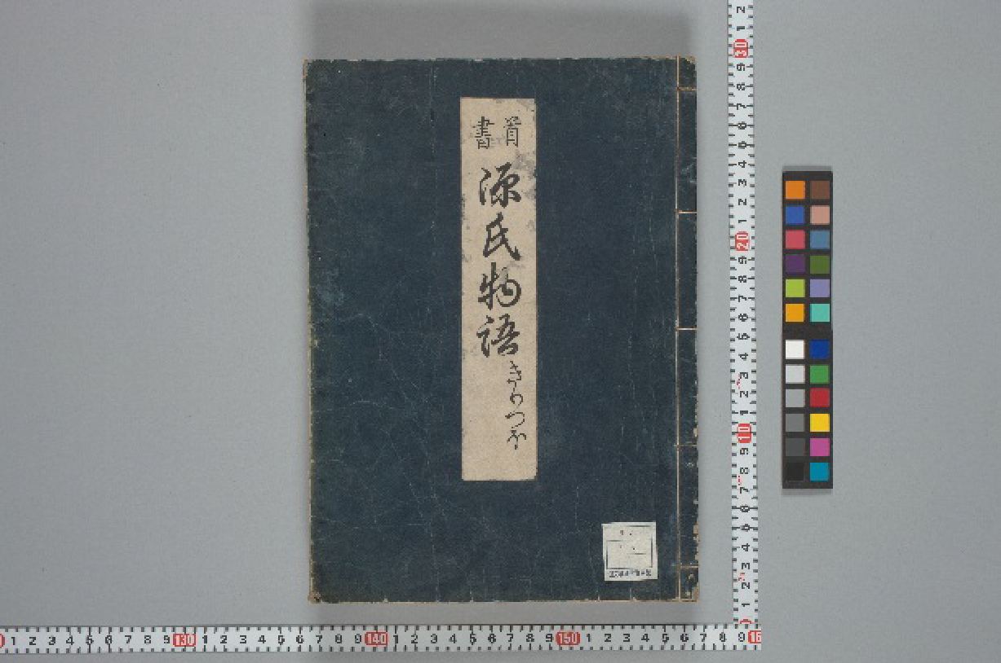

Fig. 1: A sample photograph with a scale and a color chart

1. Color chart (see fig. 1 and fig. 2)

・The size of the color chart should be less than 130% of the height of the material.

・Always use a color chart that has not deteriorated.

・A color chart should be included in the first frame of “box,” “bookcase,” and “wrapper/envelope,” and the first and the last frame of the “main document” (both the front and the back cover, if the material has a cover) of each material.

・Place a color chart horizontally or perpendicularly to the material as much as possible.

・Provide adequate margins between the material and the color chart.

・For ICC-based color management, the Adobe RGB (1998) is recommended for storing RGB image files (24-bit full color).

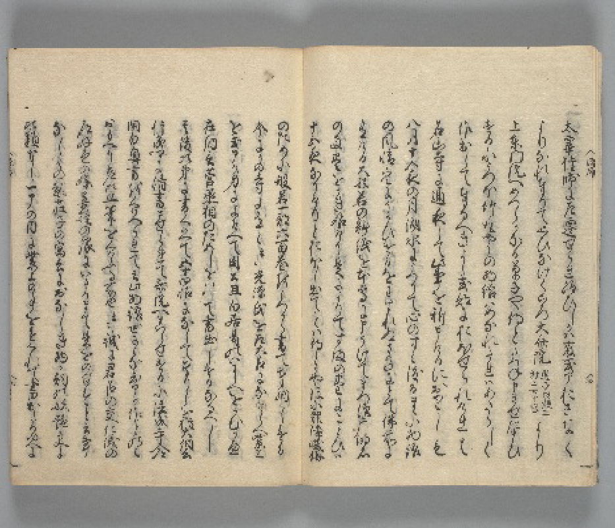

Fig. 2: A sample photograph with the facing pair of pages shown

1. The reduction rate should be handled as follows:

(1) The percentage of area occupied by the photographed material in the frame should be 50% or more of the effective image area, with the facing pair of pages shown in a standard book form (see fig. 2).

(2) Do not change the reduction rate of a single material midway through. If the reduction rate is changed midway through, a scale must be photographed again in the frame where the reduction rate was changed.

(3) If the material cannot fit in one frame using the reduction ratio specified in (1) above, one of the following methods can be used:

・If the target material can be rotated 90 degrees to fit in one frame, rotate the target material 90 degrees clockwise and take the photograph. (If the image was taken in a rotated orientation, the image data should be rotated and corrected so that the target material faces front.)

・If the target material cannot fit in one frame even after rotating it 90 degrees, separate images should be taken. In this case, write the shooting order using Attachment form (1): Split shooting order sheet (分割撮影記録票), which should be photographed and inserted into the frame immediately before the split shooting. Adjacent areas should be captured to clarify the location of the subject material.

・The above-mentioned split photography should apply to illustrations and folded inserts, and not to scrolls.

1. Creating image files:

* Each image file must be named according to the following structure:

“[the name of the folder]-[the sequential number for the images within the material].[extension].”

e. g., 0225-000101-00001.tif

e. g., 0225-000101-00001.jpg

・The name of the folder should match the material number provided by NIJL. In the above examples of image files, “0225-000101” represents the name of the folder.

・The sequential number should be 5 digits (zero padding), starting from 00001.

・The extension of the image file should be either "tif" for TIFF or "jpg" for JPEG (use lower case).

・The image files with the same folder name should be placed in a single folder under that folder name. Do not create a folder within a folder. TIFF and JPEG files must be placed in a different folder.

1. Creating folder name lists:

The grant recipient is responsible for providing NIJL with a folder name list in Excel using [Attachment form (2)](https://docs.google.com/spreadsheets/d/1px1yYRgt6xZWlbIzM4Iw_ME8fK_XeAQW/edit#gid=1317238147). Please refer to the following for the entry names and contents that should be included in the folder name lists:

(1) Image folder name: The name of the folder that contains image files should match the material number provided by NIJL.

(2) Total number of images: Total number of image files stored in the individual folder

(3) File size (GB): Individual folder’s file size

(4) Image format type: Put either TIFF or JPEG

**Attachment Form (1):**

**Split Shooting Order Sheet (分割撮影記録票)**

**Image folder name:**

**Image file names taken in split shooting:**

From:

To:

**Split shooting configuration and their shooting order:**

(Below is a sample of the split shooting in nine parts – Revise the image below as needed)

| 7 | 4 | 1 |
| --- | --- | --- |
| 8 | 5 | 2 |
| 9 | 6 | 3 |